**LINUX COMMANDS – TASK01**

**File Creation Task**

**Task Description:**

1. Create a directory called ""my_folder"", navigate into it, and create a file named ""my_file.txt"" with some text. Then, create another file named ""another_file.txt"" with some text. Concatenate the content of ""another_file.txt"" to ""my_file.txt"" and display the updated content. Finally, list all files and directories in the current directory.  
     
   **Created a script to make this happen,**

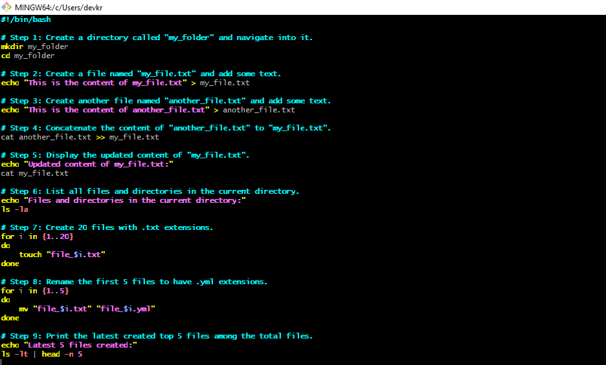

Create 20 files with .txt extensions and rename the first 5 files to .yml extension and Print the latest created top 5 files among the total no of files".

**Ran the script to have the output**

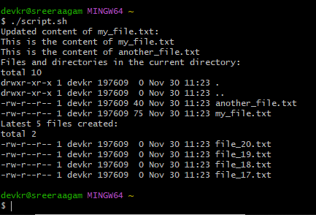

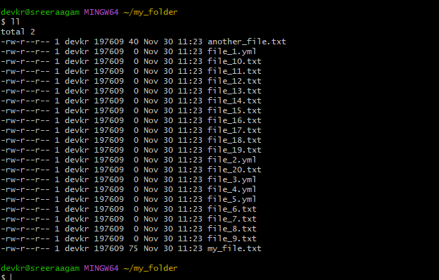

**Techstacks needs to be used :**

Shell (AWS, Gitbash, WSL, Vbox) :  **Installed Gitbash in my manchine**

**How do I submit my work?**

* Push all your work files to GitHub (O/P screenshot images must).

**Git clone** [**https://github.com/sreejesht/sreetasks.git**](https://github.com/sreejesht/sreetasks.git)

**https://github.com/sreejesht/sreetasks**

* Submit your URLs in the portal.

**Terms and Conditions?**

* You agree to not share this confidential document with anyone.
* You agree to open-source your code (it may even look good on your profile!). Do not mention our company’s name anywhere in the code.
* We will never use your source code under any circumstances for any commercial purposes; this is just a basic assessment task.

**NOTE:** Any violation of Terms and conditions is strictly prohibited. You are bound to adhere to it.